EXPERIMENT 14
Demonstrate how to work collaboratively in Git/GitHub on a project
using the fork-and-pull request workflow.
Tasks:
1. Fork an existing public GitHub repository (e.g., a sample
JavaScript or Python project).
2. Clone the forked repository to your local machine using Git.
3. Create a new branch for the feature or change you want to
work on.
4. Make modifications or add new features (e.g., add a function,
fix a bug, or update the README).
5. Commit your changes and push the branch to GitHub.
6. Go to the GitHub repository and create a pull request to merge
your feature branch into the main branch.
7. Review the pull request and provide feedback on the changes.
8. Respond to feedback by making additional commits to the
feature branch if necessary.
9. Once the pull request is approved, merge it into the main
branch.
10. Finally submit the link to the pull request along with a
summary of the changes you made and how you collaborated.

Step 1: Open GitHub Repository
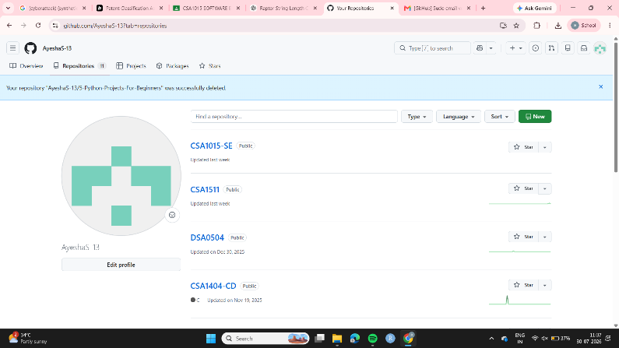

Step 2 Open the repository:
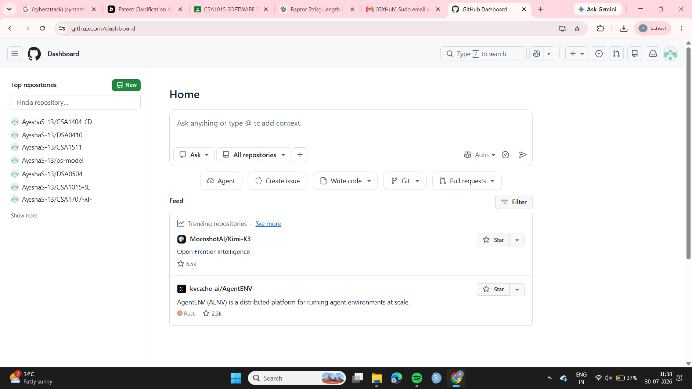
Step 3 – search for 5-Python-Projects-For-Beginners
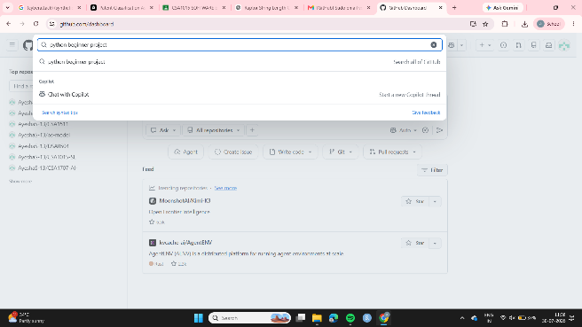
Step 4 – select anyone of the project
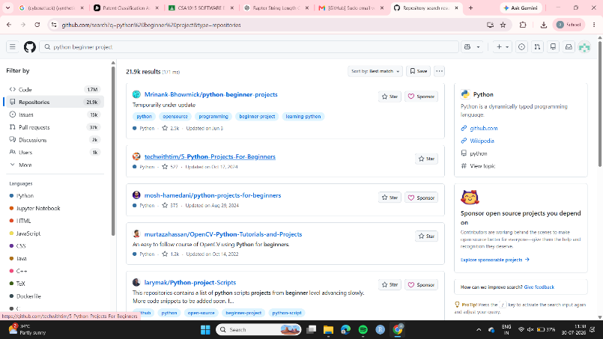
Step 5: Copy Repository Link
- Click on Code (green button)
- Copy the HTTPS URL
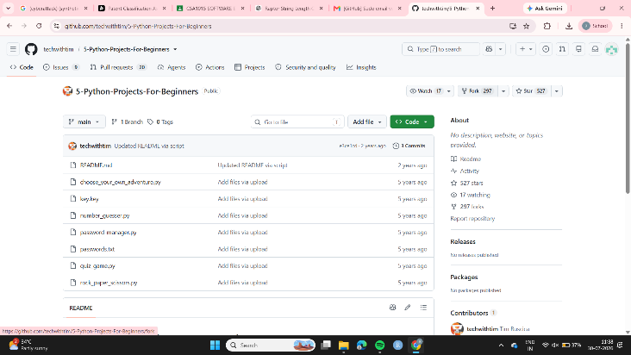
Step 6- create a new fork
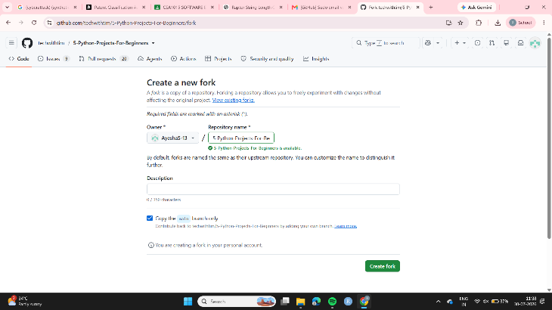
Step 7 – copy the url
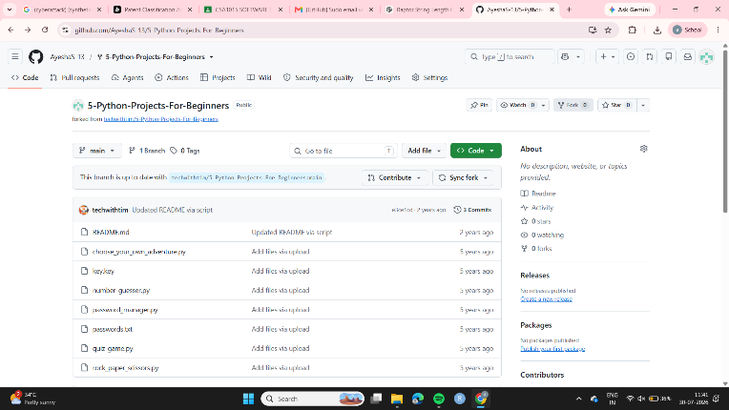
Step 8: Open Git Bash
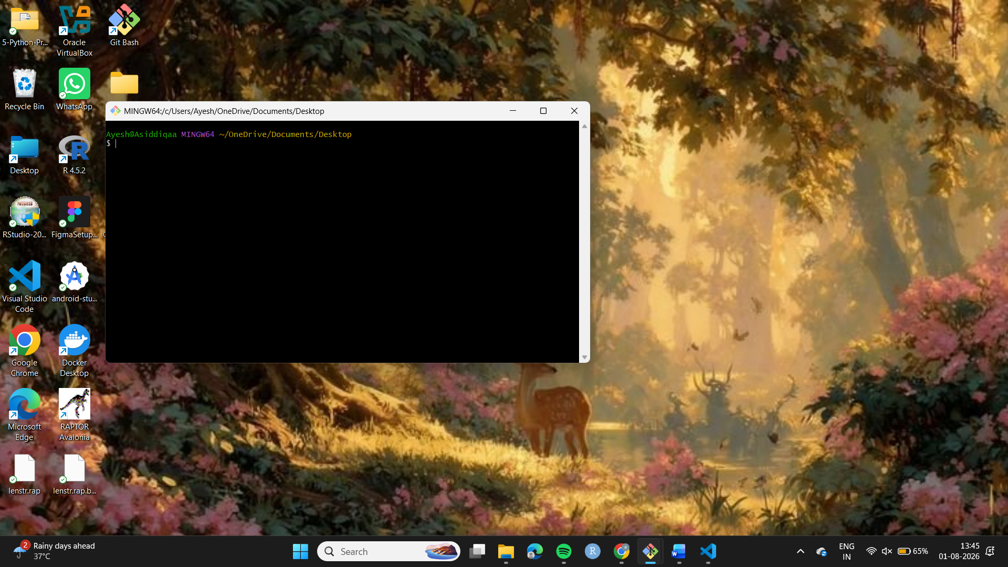
Step 9- : Clone the Repository
git clone https://github.com/AyeshaS-13/5-Python-Projects-For-Beginners.git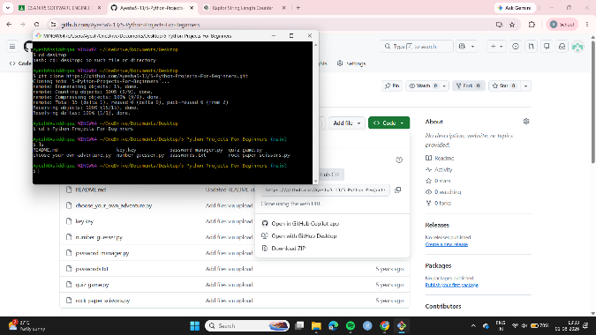
Step 10: Navigate into Folder
Step 11: View Files
Step 12- Run Python Program
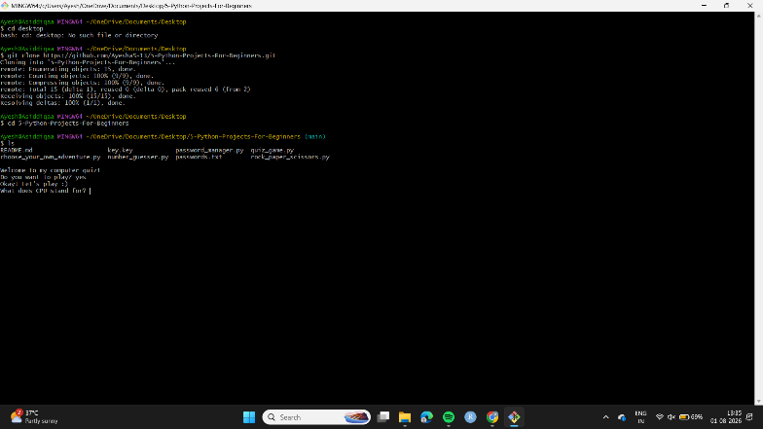
OUTPUT
